COMP2000 - Coursework 1 30%

**Exercise 1:**

**Users of the system**

Admins

Goal: To be able to efficiently manage employee records and approve/deny holiday requests. To ensure the salary increases are applied automatically.

Characteristics: Admins may be more experienced with using admin tools, so may find manual management inefficient and prefer an automated system. They will most likely be HR managers.

Admin Tasks

Admins will be notified when an employee requests a holiday. This means that they can also approve or decline employee holiday requests. Admins will manage employee details by adding, editing or deleting them off the system. The system will automatically apply a 5% salary increase when an employee completes a year of working.

Employees

Goal: To be able to update and view personal information and to request holidays.

Characteristics: Employees will vary in technological skills, meaning that the interface will need to be simple and user friendly. They may be frustrated if holiday requests and processed quickly or if the app is too complicated for them to complete basic tasks (editing details or requesting holidays)

Employees will be able to view and update their own personal details (such as address, phone number etc). They can request their own annual leave (30 days per year) and will be notified when their holiday request is accepted or denied.

**Context of Use**

The system requires the users to log into their accounts to be able to complete tasks. The app will access the data store through the RESTful API web service, for admins that need to manage employee data via HTTP. Push notifications can be sent to users based on their preferences (either on or off).

Admins and employees are required to collaborate through the app, for example, an employee may request a holiday, and the admins will respond by approving or denying the request. The communication is done through push notifications, however these can be turned off depending on the user’s needs.

The mobile application is intended to be used on various mobile devices, meaning that the interfaces should vary resolutions and dimensions to fit each phone. Due to it being a mobile app, this means that the employees and admins may use it at work or on the go.

There are no set time constraints or limits when it comes to users managing their tasks. However, notifications about holiday requests or approvals/declines need to be timed so that both employees and admins will see the changes promptly.

Some admins may have more authority than others, meaning that there may be a hierarchy, with some admins only able to manage employee data and others managing employee holiday requests. However this was not specified.

**Exercise 2:**

Employee and Administrator Prototype

Employee Side Prototype

Admin Side Prototype

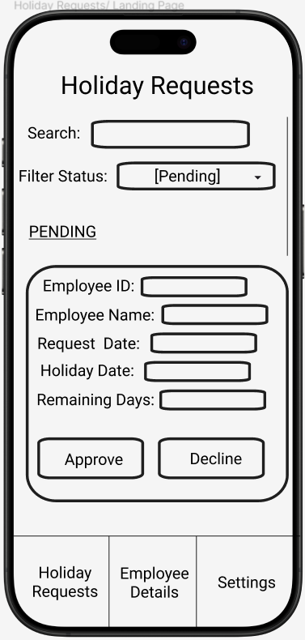

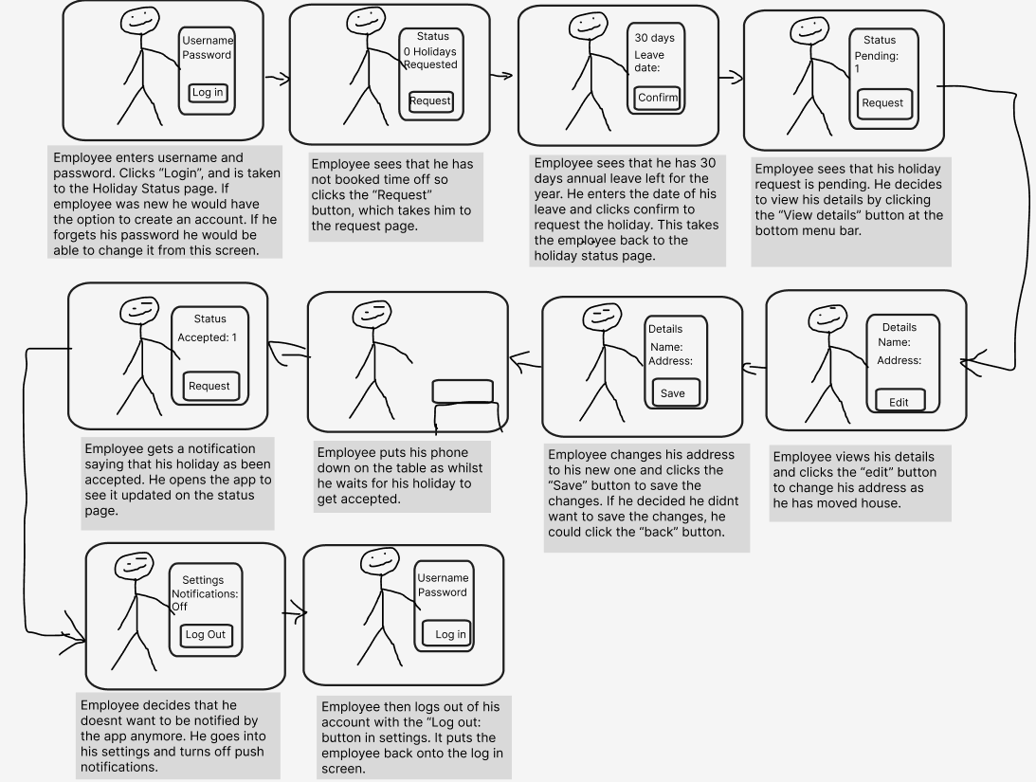Employee Storyboard

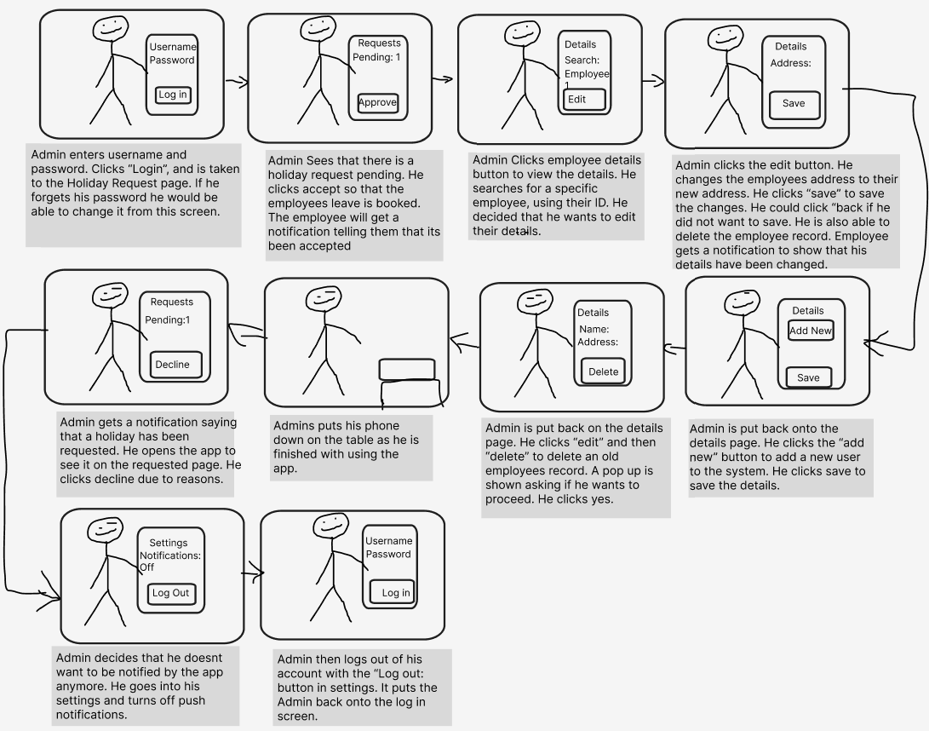Admin Storyboard

Employee prototype - Wireframe

Admin prototype - Wireframe

**Exercise 3:**

**Formative Usability Evaluation Process**

1. **Study Overview**

Objective: To evaluate the usability of a paper-based, low fidelity digital prototype, of an admin and employee interface for a mobile application. By observing potential users interacting with the design.

1. **Participants**

**Participant 1:**

* Name: Bethan Angove
* Age: 19
* Occupation: Student at University of Exeter

**Participant 2:**

* Name: Claire Fish
* Age: 47
* Occupation: Teacher

**Participant 3:**

* Name: Simon Fish
* Age: 48
* Occupation: Network Engineer

1. **Testing Plan**

**Methodology**

Conduct a survey where participants complete a questionnaire after interacting with the digital paper prototype. This will allow them to provide feedback on specific areas of the design.

**Testing Procedure**

1. **Preparation**

* Set up the testing environment ensuring that it is quiet and free from distractions.
* Prepare the digital paper prototype of the admin and employee interface.

1. **Introduction**

* The participants will be briefed on the purpose of the study and how the feedback will be used to improve the design.
* Explain that they should feel free to speak their thoughts as they navigate through the prototype.

1. **Task Scenarios**

Admin and employee

1. Log into the system
2. Identify potential challenges
3. Look for missing features

Admin

1. Navigate through the menus
2. Add a new employee to the system
3. Approve or decline a holiday request
4. Search for an employee
5. Edit an employees details
6. Manage Notifications
7. Identify potential challenges
8. Look for missing features
9. Highlight positive aspects
10. Suggest improvements

Employee

1. Navigate through the menus
2. Request a holiday
3. Check holiday request status
4. Edit personal details
5. Manage notifications
6. Identify potential challenges
7. Look for missing features
8. Highlight positive aspects
9. Suggest improvements
10. **Data Collection**

* Record any comments regarding usability, noting down any confusion or difficulties.

1. **Debriefing**

* Conduct a short interview after the tasks to gather additional feedback regarding the UI.
* Ask the participants about any confusion or overall impressions about the design.

1. **Consent Forms**A paper with text and a black pen

   Description automatically generated with medium confidence

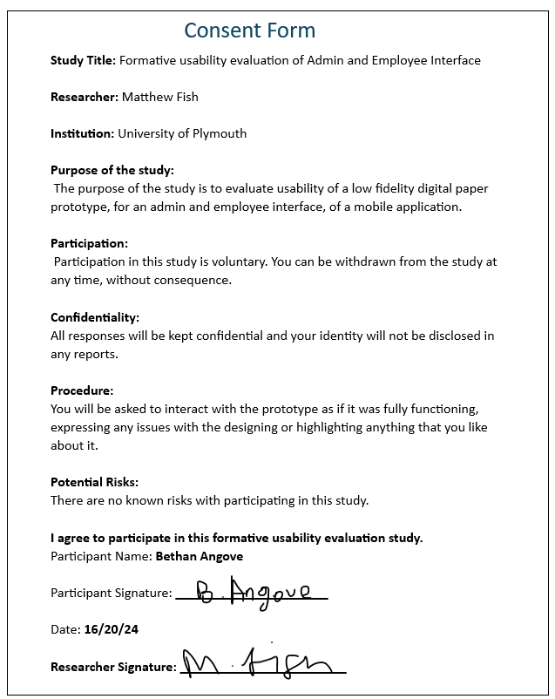

1. **Outcome of the study**

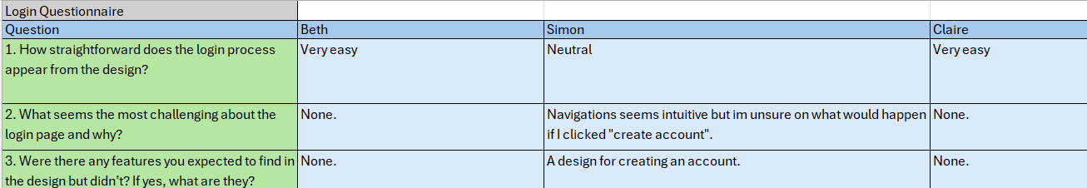**Login Questionnaire and Results**

[**https://forms.gle/5jLhUjuxuVqtGcJg7**](https://forms.gle/5jLhUjuxuVqtGcJg7)

**Admin UI Questionnaire and Results**

[**https://forms.gle/SdsCqeoErAJrrrBV6**](https://forms.gle/SdsCqeoErAJrrrBV6)

**Employee UI Questionnaire and Results**

[**https://forms.gle/YTQJ38VEPuAH6NLg7**](https://forms.gle/YTQJ38VEPuAH6NLg7)

**Summary of Findings**

General Usability

* **Ease of navigation:** Overall, the participants found the navigation of the design intuitive and straightforward. Most questions were rated either “Very easy” or “Easy”, which shows that the design is user friendly.
* **Challenging areas:** The employee details page on the admin design was found cramped and overloaded with too much information. It was also noted that there was some uncertainty about clicking the “create account” button due to no previous design and employees email being missing.
* **Visual clarity:** Nothing had been noted about the design visually with text size and placement of details. Employees detail page being cramped was the only issue.

Task Performance

* **Success Rate:** The participants found it easy to navigate and perform tasks, such as edit details, request a holiday and manage notifications.
* **Login Process:** The log in process in a whole was found simple to log in, but there was expressed confusion with “creating an account” due to their not being a design and no email address included in the details.
* **Holiday Requests:** The holiday requests process was found simple by all participants. However, some participants emphasized the need for a feature that explains why a holiday was declined. The holiday history, along with the total number of days booked was also recommended to be included.

Participant Debrief

During the debrief, participants mentioned that overall, the design looked efficient and well thought out. They didn’t have anything additional to add beyond what was shared in the questionnaire. They found the design to be straightforward, although some noted that the employee details page (in the admin section) felt a bit cluttered.

Participants also highlighted a few improvements that could enhance the user experience, such as adding a holiday comments box for declined requests and refining the design for account creation to make it clearer. These suggestions, along with the questionnaire feedback, provide a clear direction for improving the design and functionality of the app, ensuring a better user experience in future iterations.

Key Suggestions

1. **Employees details page (admin design) redesign:**

* The initial design should be simplified to only show the key information (E.g name and ID) with the additional details being revealed when editing. This will avoid clutter on the main page and make it easier to manage multiple employees at once.

1. **Forgot password and create account functionality:**

* The employees email needs to be added into the details to allow users to get sent an email when they forgot their password or create their account. A design for creating their account will also help the users understand what details are needed as it will be a part of the app.

1. **Admin comments for holiday decline and holiday history**

* A comments box should be introduced for admins to explain why they have declined a holiday request.
* The holiday history and total number of days leave for each holiday should be shown to help avoid scheduling conflicts and provide transparency.

1. **Screen size**

* Ensure that the design will fit both android and IOS devices, to ensure that all users will be able to access the application.

**Documentation of study setting**

Participant Photo and testing environment

1. **Conclusion**

The formative usability evaluation has provided valuable information about the overall user-experience of the digital paper-based prototype. Most of the participants found the design intuitive and easy to navigate through the different pages. The tasks were majority rated as “Easy” and “Very easy”, indicating that the core structure of the app is well-designed.

However, certain areas of the interface require improvement to enhance usability further. The employee details page, from the admin design, was found to be cluttered and overwhelming, therefore, it needs a redesign to be simplified.

Several participants also expressed the ability for admins to give reasons why they have declined holiday requests and to view an employees holiday history. These features would ensure that transparency and communication between the admin and employee is enhanced.

There were some other minor changes that the participants had raised, such as adding the employees email into the employee details and designing a “Create account” page to show what the users would actually need to do before logging into the app. The screen size for different mobile devices was also mentioned to be included so that all users will be able to access the app.

Moving forward, the next design will focus on improving the layout of the employee details page and incorporating the suggested features to improve the overall functionality, which will help the users understand what the final application will be. By addressing these areas, the app can better meet user needs and expectations and ensure that it is more efficient and user-friendly.

**Exercise 4:**

Employee and Admin Prototype Redesign

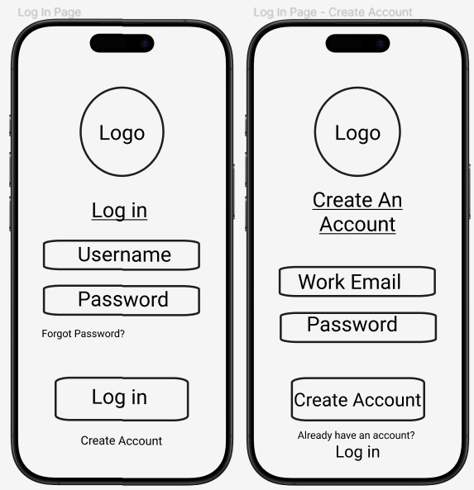

I have increased the font for “forgot password” so that it is easier to read and click on. I have created a new design for the create an account page.

The settings page for both admin and employees has not had any changes made to it.

Admin Prototype Redesign

The total number of leave days for each holiday is now clearly displayed for admins, and a comment box has been added to provide a reason when declining a holiday request. Additionally, the holiday history has also been implemented. These will enhances transparency and clarity in decision-making.

I have streamlined the page by removing some details, reducing clutter and allowing more employees to be displayed simultaneously for efficient scrolling. The hidden details will become visible when the admin clicks the "Edit Details" button, ensuring a cleaner interface while maintaining access to necessary information.

The employees email has been added to these details and I have protected some of the fields that should not be changed as the salary is automatically increased and the ID and Email will never change.

Employee Prototype Redesign

The total days of leave are now automatically calculated and displayed on the request page as soon as the holiday dates are entered, with this information also available on the status page. Additionally, a comment box has been incorporated in the decline section, allowing admins to provide reasons for rejecting holiday requests. A holiday history feature has also been introduced to enhance holiday management. While the design page may appear cluttered and full, the app will ensure that information is spread out and easily navigable when scrolling, allowing for a more organized view of all details.

The employee email address has been added to the details section, which will help eliminate confusion around the "Create Account" and "Forgot Password" processes. This ensures users can retrieve their account or reset passwords easily.

Overall, all of the designs will fit all different screen sizes for different devices, ensuring that all users will be able to use the app.

Employee Redesign Storyboard

Admin Redesign Storyboard

Admin Wireframe Redesign

Employee Wireframe Redesign

**Exercise 5 + 6:**

High fidelity Prototype Screenshots

The login button can be clicked and takes the employee to the holiday status page. The create account text can be clicked which takes the employee to the create account page. The text is editable for email and password on both pages however the email and password is not currently necessary, to log in. The buttons only need to be clicked at this stage. The employee can scroll down on the status page which reveals the holiday history. When the request holiday button is clicked, it takes the employee to the request holiday page.

The confirm and back buttons take the user back to the status page. The date fields can be edited but do not do anything at this stage. The employee can click the view details button to navigate to the personal details page. The page can be scrolled to reveal other information underneath. I have added a password to the details page as it was something that I missed when creating the designs. I also moved the button to the top of the page as it was easier to access. When the edit details button is clicked, some of the fields change from view to edit mode and can be edited by the employee. Some fields stay locked to ensure that specific data cannot be modified. The fields that can be edited do not save and have any use currently, but have been added so later functionality can be implemented.

The save button can be clicked which changes the fields from edit mode back to view mode so that they are no longer editable. The employee can click the settings button at the bottom which navigates them to the settings. They can toggle the notifications on and off however, it does not currently affect anything. The log out button can be clicked which brings a popup asking if the user is sure to log out. If they press no it dismisses the popup, if yes, the user is taken back to the login page. This was not a feature that I had though of during the design and did not receive from the feedback, however I had a similar concept with the delete employee popup for the admin page.

There is only the basic functionality so far of navigating between different pages and being able to edit fields to prepare for being able to edit and save the details for an employee. However, at this stage I have created a fully working basic high-fidelity prototype, that is based off the user feedback designs, that does the basic functions and is set up ready to implement the database for the employee to create and account, store their details, request a holiday and manage notifications.